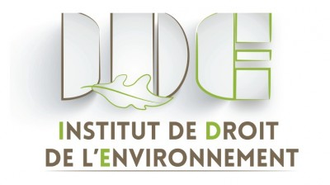

MASTER 2 DROIT DE L'ENVIRONNEMENT ET DE L'URBANISME
COURS D'ANGLAIS
Année universitaire 2018-2019
Pauline COLLOMB, professeur agrégée d'anglais, Faculté de Droit, Lyon3

1. Introduction

The class is a 15-hour course, divided into 7 tutorials.
In each tutorial, a topic relating to environment or urbanism will be studied using various documents (press articles, videos...) so students get familiar with the specific vocabulary and expressions used in this specific area of law.
The necessary documents are to be found at the end of this fascicule. Please print the fascicule and bring it with you for all classes.

2. Grading

The last hour on the schedule will be devoted to a written test. Students will be expected to answer various questions relating to topics discussed in class, in proper English.

To help you with vocabulary and expressions, here are two very useful websites you may want to visit:

http://learnersdictionary.com/3000-words/topic/the-environment

https://en.wikipedia.org/wiki/Category:Urban_studies_and_planning_terminology

Course outline

Class#1:

Introduction. US cities. Focus on Central Park.

Class#2: Politics and environment. Urbans versus Non Urbans (Press article)

Debates : Green Parties in the UK, France and the US / Farmers’ relationship to environmental issues / Climate change deniers / yellow vests*

* https://www.bbc.com/news/world-europe-46424267

* https://www.nytimes.com/2018/12/05/world/europe/yellow-vests-france.html

Class#3: Public transportation in the US: focus on Florida (Press article)

Debates: Public transports policies in Europe / Policies relating to vehicles (car pooling, electric cars, smart city, tax on diesel…) / Carbon tax: pros and cons

Class #4: Eminent domain: focus on the US (press article)

Debates: National Parks / Notre Dame des Landes and the airport issue

Class#5: the coal debate in the US and UK (video, press article)

Debates: Sustainability and green energy policies / Is clean air a fundamental right?

Class#6: Water pollution scandal in Flint, Michigan (video)

Debates: water: a right and a business / waste disposal and recycling policies / organic food: environment-friendly?

Class#7: Natural catastrophes, focus on Hurricanes in coastal US (Press article)

Debates: Designing disaster-proof city? / Oil spills and justice

Written test

